1. Write a program to enter a number of any length, and find whether its palindrome or not.

e.g., 12321 is palindrome. 12344321 is palindrome

1. Write a program to print empty diamond

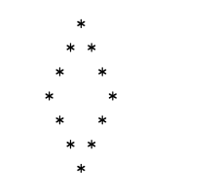

1. Print the following for n lines

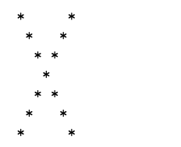

1. Print of pattern of 0’s surrounded by stars

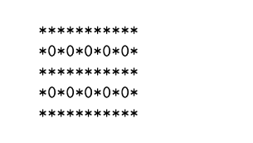

1. Print pyramid of alphabets

A

A B A

A B C B A

A B C D C B A

A B C D E D C B A

1. Write a program to enter a number and show how many times a digit appeared in number

e.g., n = 23531

1 =1 times

2 = 1 times

3= 2 times

5 = 1 times